Professional texts

1
Hi Juli,
I've attached the contract for our new freelance designer who starts working with us next month.
Could you please review the contract till Friday, June 14? I'll greatly appreciate your feedback!
Best,
James Stevens
Legal Consultant
ABC Inc.
077-333-55-66

2
Hello Tom
I'm happy to invite you to speak at the Zombie Apocalypse Conference in San Francisco (August, 21-22). Our goal is to bring together the brightest survival experts and draw public attention to the zombie apocalypse preparedness problem. I'm a huge fan of your blog "Surviving with Tom", especially the posts about creating a perfect survival kit. Last year, lots of people asked for the in-depth talk on this topic, and it would be great if you shared your expertise on the stage!
What you'll get as a speaker:
- Meet over 1,000 zombie experts all over the world
- 100% covered flight and accommodation costs
- A personal guide to help you get the most out of your stay in SF
Feel free to ask me any questions about the conference!
Please let me know by June, 24 if you're interested in speaking./
Best,
Sarah Green
Senior Event Manager
Zombie Apocalypse Conference
055-555-55-55

3
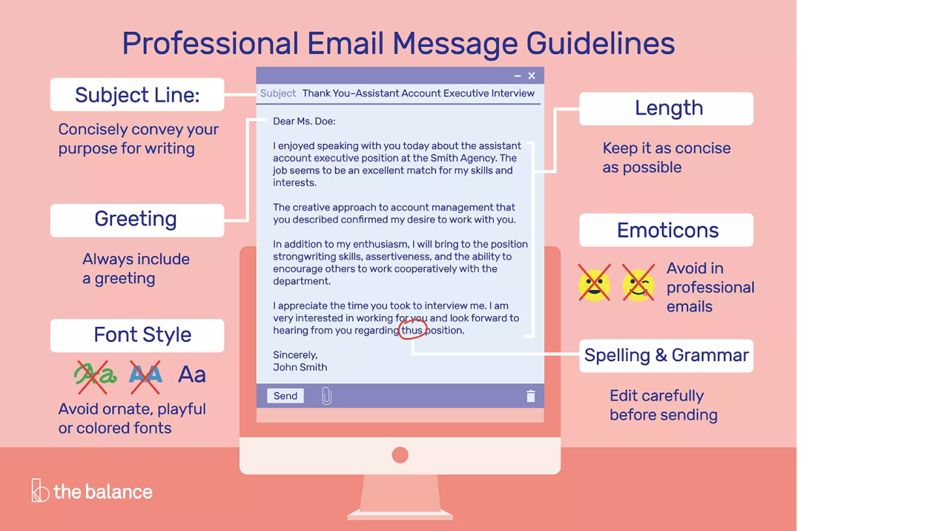

4
Example Professional Email
Dear Mr. or Ms.
I hope all is well. I had fun meeting you and designing our Career Focused Project together on Tuesday. I know we agreed that I would make a PowerPoint presentation, but I don't have any way to save my work after each session. Could you please bring a jump drive to next session? If you can't, I will ask Ms. Johnson for one tomorrow.
I am also interested in learning the importance of teamwork at your job. What do you think makes someone an effective team
player in the workforce? What type of team assignments do you normally work on? Do you prefer working in teams or on your own?
Thank you for taking the time to answer my questions and I look forward to hearing from you.
Sincerely,
Derry simit

5
Your Name
Your Address
Your City, State, Zip
Code
Your Phone Number
Novermber 3
Name
Title
Organization
Address
City, State, Zip Code
Dear Mr./Ms. Last Name:

I would like to request a ten day leave of absence for
personal reasons. My cousin is getting married on
November 12 and I would like to attend the wedding which is going to be held at our ancestral home in Kerala. And because I haven't been to my native place in over 18 months, I am also keen on spending a few days with my parents and other family members who live there.

If possible I would like to leave work on November 7 and return on November 17. I would also like to assure you that even when I am away from work, I will be constantly
accessible via email or phone.
Thank you very much for your consideration.
Sincerely,
Your Signature
Your name

6
Professional Email
Your Street Address
Your City, State Zip
Date
First and Last Name of the Person to whom you are writing
Their Street Address
City, ST Zip
Dear Mr./Ms. Full Name:

You do not want to indent when you are using this format. This is the best use when you are writing a persuasive letter. You want to introduce your the topic you are writing about to reader. Remember that the first rule is to know your audience. In a persuasive letter, you state your opinion feelings about something that is important to you after you have introduce You must sound as professional and passionate as possible. You do not belittle the reader or they will not finish reading your letter. Your letter have the facts, reasons, and examples to support your position. Address your reader may have in their argument.

In a second paragraph, you must have solutions. Without solutions, you complaining. Offer assistance in solving the problem. Remind the reader can contact you.

Sincerely yours,
A. Student

7
To whom it may concern:

My name is Earl Rivers. I'm contacting you to apply for the administrative assistant position listed on CareerXYZ.com.

8
Dear Ms.Doe,
My name is Arlene Rivers. I obtained your email address from the Westchester County Clerk website. I am writing to contest the traffic citation I received on December 31, 2009.

9
Dear Ms. Smith,
This is Darlene Frankreich. I'm a student in your CHEM 221 class, and I'm writing about a potential exam time conflict.

10
To all conference call participants:
This is a reminder to everyone about the upcoming conference call, this Wednesday, July 17 at 9:15 AM. Please make a note of the date and time and be a few minutes early so that we can make sure everyone is available. Conference call details are listed below.

Meeting time: 9:15 AM
Call number: (324) 555-0198
Call code: 3547852

Attending:
John Smith
Gary Riley

If you have any further questions, please contact my executive assistant, Terry Jones, at
(534) 555-0028.

Thank you,
John Smith

11
Formal:
Thank you for your shipment of the four ball pythons to our store, Pets Alive! on March 2, 2015. Unfortunately, two of the snakes appear to have been hurt during the delivery and were deceased when I opened the snake crate. I would like for you to send two replacement snakes as soon as possible.
Please email me or call the store with further questions or to make arrangements for a new shipment.

Informal:
Thanks for the snakes you sent. I'm sorry to say that two were dead. Send more soon, plz. Talk to ya later!

12
I hope to be a positive force during this transition period. Letting members of our community go, is always a difficult endeavor to navigate, I hope to make that transition as peaceful and productive as possibile. Please let me know how I can best serve during this time.

Sincerely,
Edward Miller

13
Hi Sakira,
I would like to take vacation February 8-14. Would that week be okay to take off?
My work on the Decatur project will be completed by then. We can hold new projects, and Adam will cover everything else while I'm out. I don't plan to take calls, but I will check my emails during the week. For anything urgent, call 555-555-5555

Thanks,
Wayne

14
To: jackmathews@yahoo.com
CC: timothyyoung@gmail.com
Subject new business relationship email
Respected Mr. Jack
1, Kell Anthony, the owner of Fiscal Group of Companies am writing this mail to you to formally start this new business association between our companies. I would begin by telling you that we are very glad to be associated with your prestigious business firm and will try to take this relationship well ahead in the future.

Your company Redding London Private Limited is respected firm which works on the same principles which we to follow. This relationship is not only beneficial for us but for you as well and I would urge you to work towards building this into a very successful collaboration. Through mutual understanding, the right synchronization of actions and financial honesty, we must squeeze out the best possibilities for ourself.

I would like to inform you that I have signed the contract and am attaching a signed copy for your reference. Hope to have a great relationship with your firm.

Yours sincerely,
Kell Anthony

Read more at http://www.sampleemails.org/new-business-relationship-email.html#JelBmllx.JVO2Vfto.99

15
